**DAILY ONLINE ACTIVITIES SUMMARY**

|  |  |  |  |
| --- | --- | --- | --- |
| **Date:** | 8/07/2020 | **Name:** | Krishnitha |
| **Sem & Sec** | 4th sem, A Section | **USN:** | 4AL18CS039 |
| **Online Test Summary** | | | |
| **Subject** | Design and Analysis of Algorithm | | |
| **Max. Marks** | NA | **Score** | NA |
| **Certification Course Summary** | | | |
| **Course** | Programming for Everybody (Getting started with python) | | |
| **Certificate Provider** | Coursera | **Duration:** | 3 hrs |
| **Coding Challenges** | | | |
| **Problem Statement:**  Write a java program to find whether the given strings are anagram. | | | |
| **Status:** Executed | | | |
| **Uploaded the report in GitHub** | | YES | |
| **If yes Repository name** | | <https://github.com/krishnitha/Java-coding> | |
| **Uploaded the report in slack** | | YES | |

**Certification Course Details:**

Today I started the new course “Programming for Everybody (Getting started with python)” by Coursera. Today I learnt about Introduction of python programming and some basic syntaxes. I have completed week1 portion of this course.

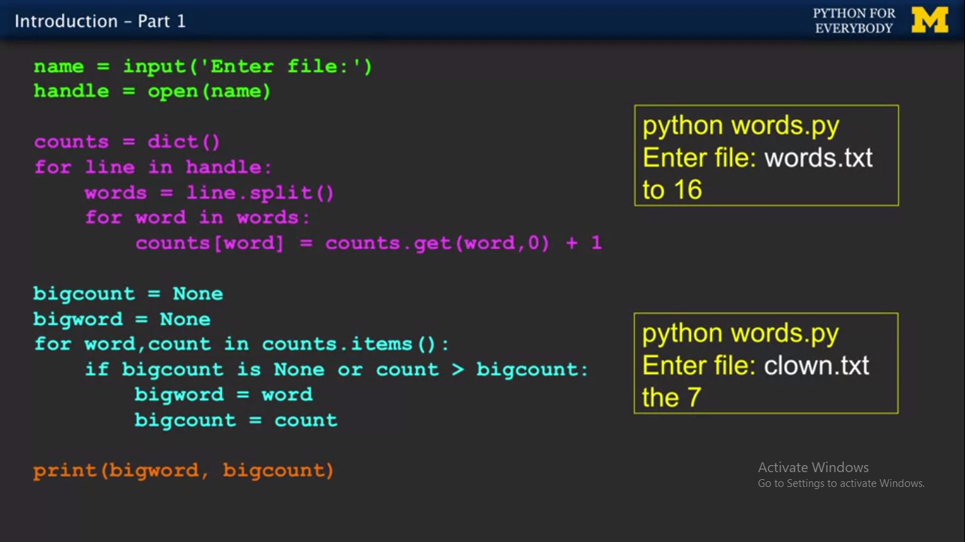

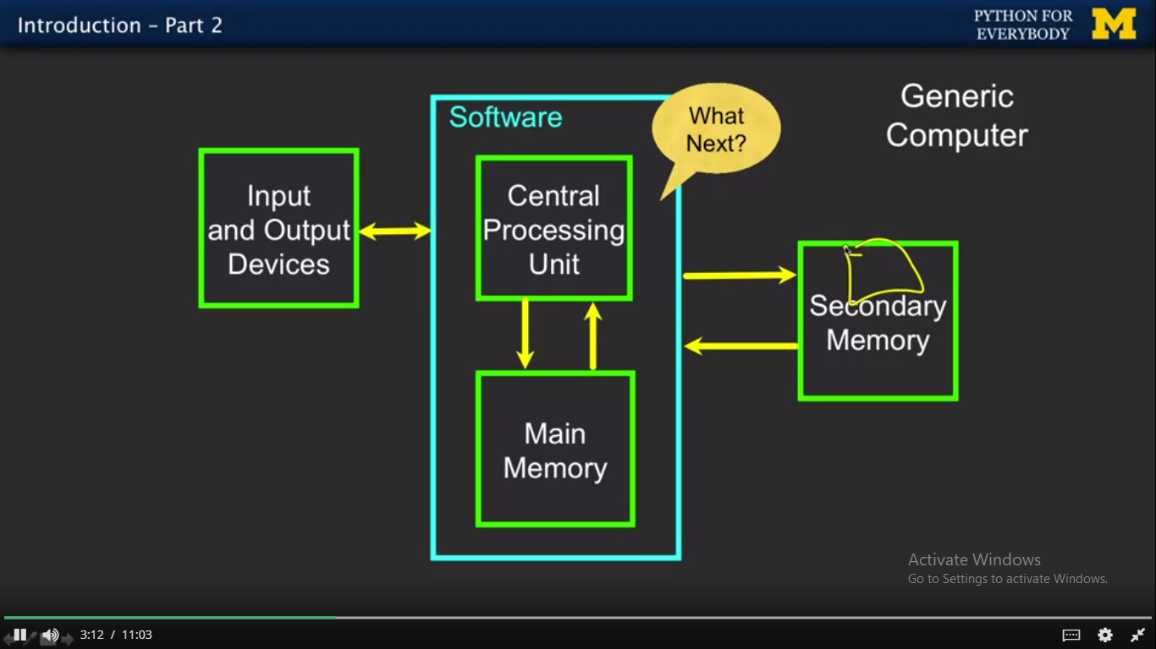

**Coding Challenges Details:**

**Problem:** Write a java program to find whether the given strings are anagram

Given two strings a and b consisting of lowercase characters. The task is to check whether two given strings are anagram of each other or not. An anagram of a string is another string that contains same characters, only the order of characters can be different. For example, “act” and “tac” are anagram of each other.

**Example:**

**Input:**  
alvasinsitute aalvsiittnsue  
allergy allergic

**Output:**  
YES  
NO

**Explanation:**  
Testcase 1: Both the string have same characters with same frequency. So, both are anagrams.  
Testcase 2: Characters in both the strings are not same, so they are not anagrams.

**Solution:** Uploaded it in GitHub

